**Public Input Needed on Dealing with Natural Disasters**

The Capitol Region is active in planning for natural hazards mitigation to help reduce our vulnerabilities to natural disasters and enable our communities to minimize losses and recover more effectively when disasters do occur.   The Capitol Region Council of Governments (CRCOG), along with each of the 38 municipalities in the Capitol Region is currently updating the Capitol Region Natural Hazards Mitigation Plan.

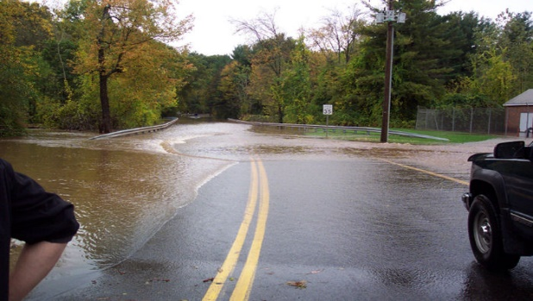

**We want to hear from you.** Please take a few moments to complete a [survey](https://www.surveymonkey.com/r/CRCOGNHMP) – your input will help shape the plan.

Also, please attend one of the public workshops we will be holding throughout the region in May. At these meetings you can learn about the plan, ask questions, and provide input.  Members of the public may attend any of the meetings, regardless of which community they are from.  The same information will be presented at each meeting.

* Tuesday, May 1 at 7:00 PM at the Ellington Town Hall (55 Main Street)
* Wednesday, May 16 at 7:00 PM at the Coventry Parks and Recreation Facility “Mill Brook Place” (near 1267 Main Street and across from Bidwell Tavern)
* Tuesday, May 22 at 7:00 PM at the Simsbury Public Library (725 Hopmeadow Street)
* Thursday, May 24 at 5:00 PM at the Hartford Public Safety Complex (253 High Street)
* Tuesday, May 29 at 7:00 PM at the Plainville Public Library (56 East Main Street)

Comments or questions can also be emailed to Lynne Pike DiSanto at [lpikedisanto@crcog.org](mailto:lpikedisanto@crcog.org)

If you would like more information about this plan update, please call David Murphy, Manager of Water Resources Planning, Milone & MacBroom, Inc. 203.271.1773 x 295. Milone & MacBroom is the project consultant for the plan update. Also, visit [CRCOG’s website](http://bit.ly/CRNHMP) for more details.