Below are two “e-flyers” that we would appreciate if you could help us distribute. They are advertising our public survey that asks for information on places throughout the region that could use some complete streets attention. If you have any email lists or facebook pages you can post this to, we would greatly appreciate it. I have also attached the press release we sent earlier in case you want to use some of the text. The bit I am quoting below is pretty short and gets the point across:

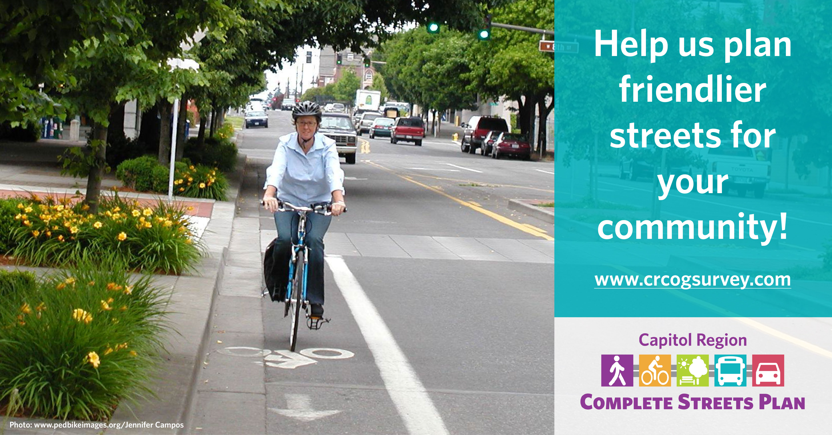The Capitol Region Council of Governments (CRCOG) has kicked off a project to develop a regional complete streets plan. Planners at CRCOG define “complete streets” as streets that are “designed and operated to enable safe access for all users, including pedestrians, bicyclists, motorists and transit riders of all ages and abilities”. CRCOG is asking the citizens of the region to help out by identifying locations where improvements may be necessary or desirable. An online survey is available at: http://crcogsurvey.com/

