**CRASH RESPONDER SAFETY WEEK NOVEMBER 8 – 14, 2021**

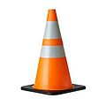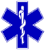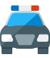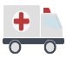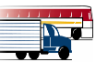

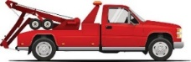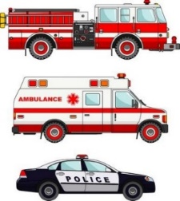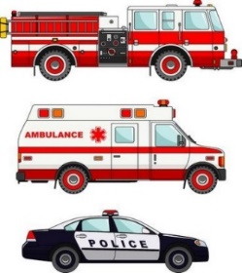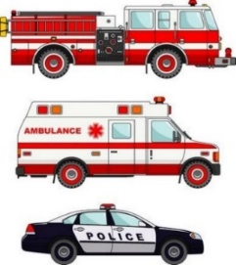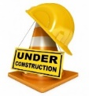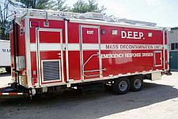

Ley del Estado

Moverse o reducir la velocidad

para vehículos de emergencia o de mantenimiento detenidos

State Law

Move Over or Slow Down

for Stopped Emergency or Maintenance Vehicles

**Steer Clear of Crash Responders**

**Move Over & Slow Down! It’s The Law**

**#CRSW #MOVEOVERSLOWDOWN**

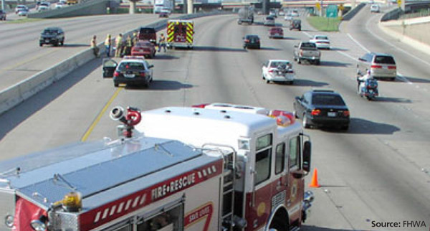

**Steer Clear of Tow Trucks**

**Slow Down & Move Over!**

**It’s The Law**

**#CRSW #MOVEOVERSLOWDOWN**

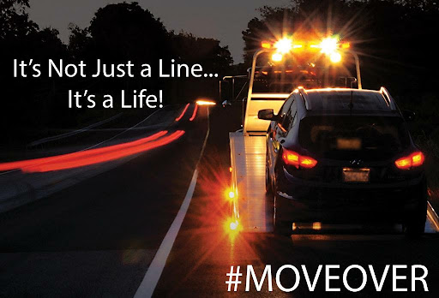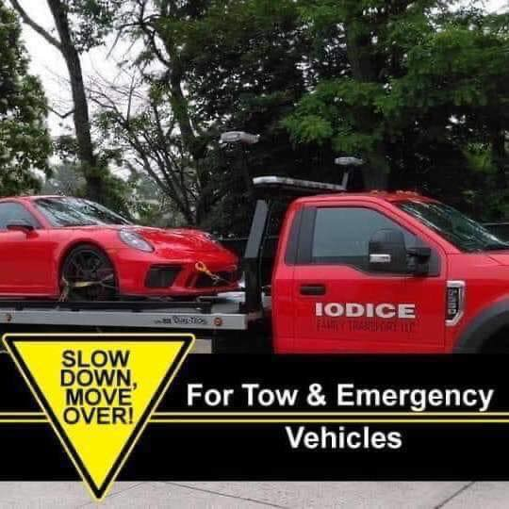

**Northeast Towing & Transport**

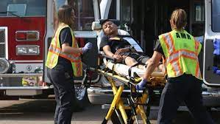

**Each year hundreds of responders on our roads are killed or seriously injured.**

**Watch Out for Us! Our Lives Depend on It!**

**#CRSW #MOVEOVERSLOWDOWN**

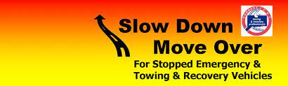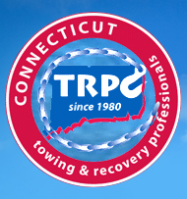

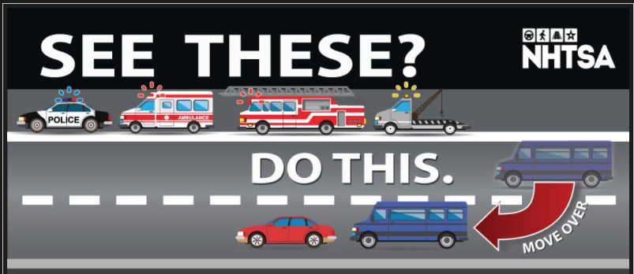

**TEACH YOUR TEEN TO MOVE OVER**

**Giving emergency vehicles space helps keep everyone safe.**

**#CRSW #MOVEOVERSLOWDOWN**

**Emergency responders (police, fire, medical, towing, etc.) risk being killed or injured by passing vehicles when on the scene of a roadside emergency. 50 responders so far this year have been killed when struck by a vehicle while responding to a roadway incident, according to the Emergency Responder Safety Institute (ERSI).**

**#CRSW #MOVEOVERSLOWDOWN**

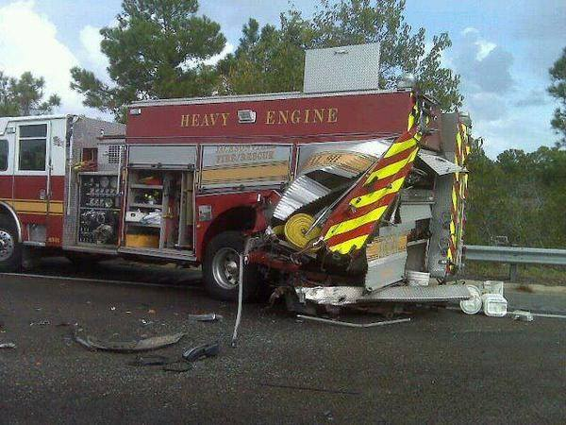

**Crash Responders put their lives on the line every hour of every day on our roadways Please slow down and move over to keep us and keep you safe!**

**#CRSW #MOVEOVERSLOWDOWN**

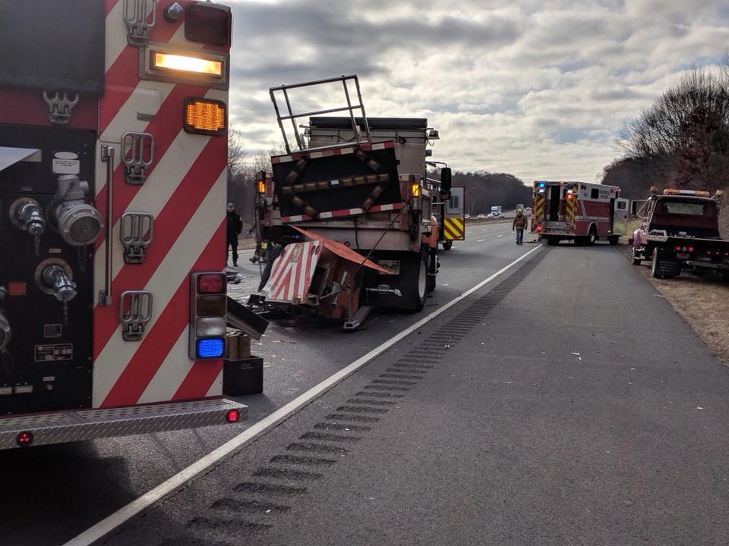

**The goal of Crash Responder Safety Week is to reach out to every responder, and to every driver, and to every passenger, to make it clear that every person has a role to play.**

**Every minute of everyday emergency responders across the country work to help save lives at the scene of traffic incidents. Too many are struck on scene. Too many are dying.**

**Be Trained, Be Educated, Be Aware**

**Be Responsible**

**#CRSW #MOVEOVERSLOWDOWN #SUBTRACTTHEDISTRACTION**

