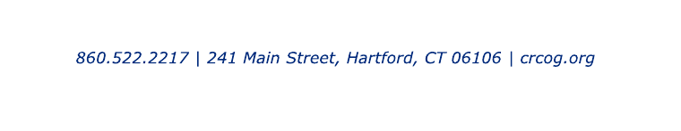

Safe Streets and Roads for All (SS4A) Grant Program
Intent to Apply Form

Please complete and submit to rkrahn@crcog.org by July 28, 2022.

Municipality:

Contact Person (Name, Email, Phone):

Anticipated Project Cost:

Type of Application (Action Plan or Implementation Grant):

For an Implementation Grant, also supply the following additional information:

Project Name/Location:

Roadway Ownership (State/Municipal/Both):

Would your Municipality be willing to have your project combined into a multijurisdictional application?
If yes, would your Municipality be willing be the Lead Applicant for a multijurisdictional application?

Because projects must be included in a Safety Action Plan, identify the page number where this project appears within CRCOG’s Regional Transportation Safety Plan or indicate that you will be self-certifying a different plan wherein this project is included:

Briefly describe the project, including its major components, the proven safety countermeasure(s) being proposed, and whether any preliminary work has been completed. Feel free to attach additional information if available:

