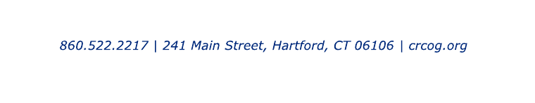

Bipartisan Infrastructure Law
Interest Form

Please complete and submit to esanderson@crcog.org by the deadline indicated below

Municipality:

Contact Person (Name, Email, Phone):

Interested?
Yes No
☐ | ☐ | - Enabling Middle Mile Broadband Infrastructure Program (Grant Application Due 9/30/2022, Responses Due to CRCOG by 9/1/2022)  https://www.internetforall.gov/program/enabling-middle-mile-broadband-infrastructure-program  Project Name/Location:  Brief Description of Project:  Is the Project located in an unserved or underserved area?:  Estimated Project Cost:  Ownership:

Feel free to attach additional information, if available. Once responses are received, CRCOG will follow-up with the Contact Person identified above to review additional information about this program.

