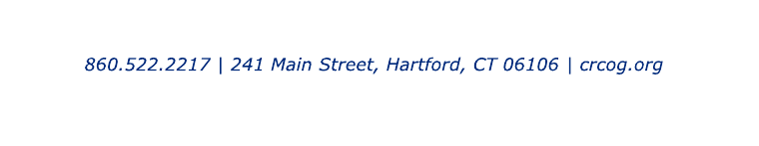

Bipartisan Infrastructure Law
Interest Form

Please complete and submit to esanderson@crcog.org by the deadline indicated below

Municipality:

Contact Person (Name, Email, Phone):

Interested?
Yes No
☐ | ☐ | - Reconnecting Communities (Round 1 Grant Application Due 10/13/2022, Responses Due to CRCOG by 9/13/2022)  https://www.transportation.gov/grants/reconnecting-communities  Project Name/Location:  Type of Grant (Planning or Capital Construction):  Is the Project located within a Disadvantaged Community?:  Status of Environmental Review:  Brief Description of Project:  Owner of Eligible Facility (State/Municipal/Both):

Feel free to attach additional information, if available. Once responses are received, CRCOG will follow-up with the Contact Person identified above to review additional information about each program.

