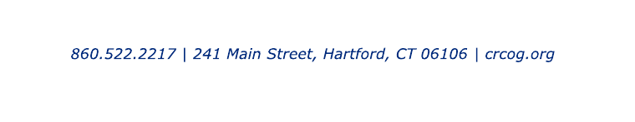
Transportation Cost Review Sub-Committee Meeting
Monday, March 20, 2023
11:00 AM
DRAFT
Until Endorsed by Committee
Hybrid Meeting

Name Organization
Larry Baril Avon
Jon Colman Bloomfield
Michael Ahern Berlin
Todd Penney Coventry
Russ Arnold Farmington
Frank Dellaripa Hartford
Jeff LaMalva Manchester
John Carrington Mansfield
Peter Hughes Marlborough
Steve Sopelak Rocky Hill
Adam Kessler Simsbury
Karen Isherwood Suffield
Greg Sommer West Hartford
Derrick Gregor Wethersfield
Bob Jarvis Windsor

Guests
Jonathan Thiesse Bloomfield
Joe Balskus VHB
Dale Abbott VHB
Will Britnell VHB
Eric Tang VHB
Daniel Amstutz VHB
Frederick Kulakowski CTDOT
Stephen Bruno CTDOT
Colin Baummer CTDOT
Jonathan Corilla CTDOT
Christopher Lockhart CTDOT
Ed Sabourin CTDOT

CRCOG Staff
Robert Aloise, Mike Cipriano, Ryan Faulkner, Chris Henchey, Roger Krahn, Sotoria Montanari, Caitlin Palmer, Pramod Pandey, Cara Radzins, Elizabeth Sanderson, Karen Stewartson

The record below includes a brief description of each agenda item as well as the timestamp of the beginning of that discussion. The audio recording for this meeting is available at: Cost Review Sub-Committee Meeting - CRCOG | Capitol Region Council of Governments

1. Roll Call – 0:00 –The meeting was called to order at 11:01 am Chair Jon Colman from the Town of Bloomfield. Ms. Cara Radzins mentioned to the Committee that there is a new feature in zoom that will collect the roll call moving forward.

2. Public Forum – 3:32 – No one chose to speak.

3. Adoption of Minutes: Cost Review Sub-Committee Meeting on January 23, 2023– 3:42 – Steve Sopelak from the Town of Rocky Hill made a motion, seconded by Russ Arnold to approve the minutes from the Cost Review Sub-Committee on January 23, 2023. This motion was passed unanimously.

4. Regional Roundabout Screening-Progress Update – 4:44
- Screening Methodology Memorandum
- Roundabout Screening Ranked Locations
- Top 100 Ranked locations
- Municipal Top 3 Ranked Locations
- Municipal Suggested Locations
- Top 100 Ranked Locations-Score/Ranking Calculations

Mr. Roger Krahn gave a brief overview on the Regional Roundabout Screening-
Progress update. Mr. Roger Krahn stated that the purpose of the screening is to identify locations of intersections in our region, on both sate and locally owned roadways that are best suited for conversion to a single lane roundabout, with a primary goal of reducing serious crashes. The consulting firm VHB gave a presentation on the progress of the following items listed above. After the presentation and several discussions, a link was shared with the Committee to access the application and provide comments, suggestions, questions for locations in your community. All inputs are due by April 3, 2023. https://vhb.maps.arcgis.com/apps/webappviewer/index.html?id=6872df4104d64911bc7b2f0e17303863 The complete presentation can be found HERE

5. Other Business– 39:37-There was no other business discussed.

- The next Cost Review Sub-Committee meeting is scheduled for April 24, 2023 (Virtual).

6. Adjourn – 39:57 – The meeting was adjourned at 12:53 pm via motion by Larry Baril from the Town of Avon, seconded by Greg Sommers from the Town of West Hartford.

