Greater Hartford TIM Coalition Meeting
Draft until approved at next meeting
Capitol Region Council of Governements
241 Main Street 4th Floor, Hartford, CT. 06106
March 29, 2023
10:00 a.m. to 12 Noon
Name | Organization
Terri Thompson | CRCOG TIM Program Coord. /Coalition Chair
Andrew McCaul | Pioneer Valley Planning Commission
Aidan Neely | CTDOT TIM Coordinator
Betty Morris | CT EMS- North Central Connecticut Emergency Medical Services Council
Cara Radzins | CRCOG Transportation
Diane Duva | CT DEEP - Emergency Response Planning & Support
Ed Brickner | Federal Motor Carrier Safety Administration
John Blair | Motor Transport Association of CT
Richard Donovan | Naugatuck Valley Council of Governments
Rob Derry | IBI Group, CTDOT Consultant for TIM program
Roger Krahn | CRCOG Transportation - Safety
Pete Silva | CTDOT Bridgeport Operations Manager (IBI Group)
Tim Vibert | TRPC- Towing & Recovery Professionals of CT
Eileen Colonese | TRPC- Towing & Recovery Professionals of CT
Emily Hein | DEMHS Region 3

MEETING MINUTES

The meeting was called to order by T. Thompson at 9:46 a.m. This was a hybrid meeting held in person and via Microsoft Teams.

- ROLL CALL
- ADOPTION OF MEETING MINUTES
- Motion to approve December 8, 2022, meeting minutes by Tim Vibert and seconded by Aidan Neely. The adoption of minutes was approved unanimously.
- EV/Hybrid Presentation -Angela Roper Cancelled for future date.
- New products in the world of TIM - Aidan Neely
Adding some products into TIM Training and reviewed in classes and getting more products to demo.
- Guardian Angel Elite 2022, https://www.guardianangeldevices.com
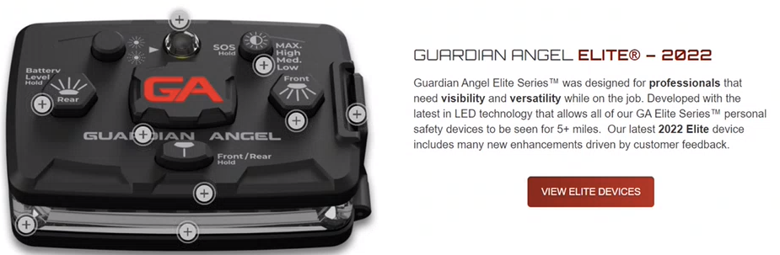
- Firstgard barrier https://www.pss-innovations.com/safety-products/traffic-supplies/firstgard
DOT has obtained demo product. It is MUTCD compliant.
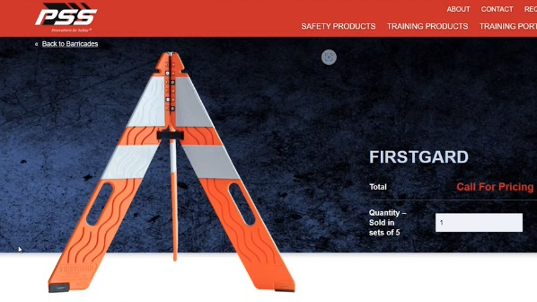

- Pi-lit Smart Sequential Road Flares https://pi-lit.com/fire-rescue/ Does have magnets and DOT has some to demo.
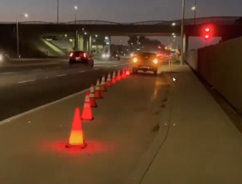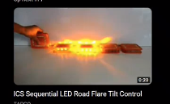

- LED Lighted safety vests https://nightlightsafety.com/ DOT does have some to demo
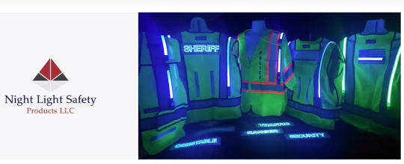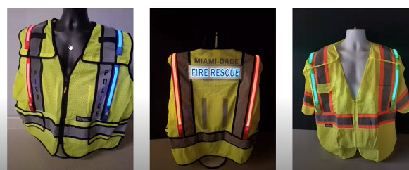

Aidan emphasized the importance of wearing appropriate PPE which adds to the level of safety. Shows video of incident within Cromwell with trooper and firefighter https://www.youtube.com/watch?v=xNnuP3sUu1U

- Draft MMUCC 6th Edition Federal Register Notice for Public Comment. Public comment period ends on April 3, 2023. T. Thompson submitted comments related to proposed revisions on 2/10/23.
- Inclusion of "P6. Special Function" data element in crash reporting and concur with Highway Safety Rationale. Also, in support of Edit Rule ER.028 in Appendix C. Request to add attributes to define “pedestrian.”
- D10 Related Factors - Driver level: The number of attribute values is very comprehensive and the ability to select up to four (4) may result in those listed in Remarks section being omitted which prevent collection of these attributes. They are important in developing a robust database on driver behavior factors to implement road safety strategies and countermeasures.
- Chapter 7, P17. Law Enforcement Suspects Alcohol Involvement and P19. Law Enforcement Suspects Drug Involvement. Comment- These data elements should not be included unless probable cause exists or if a determination is made by a drug recognition expert.

UPDATES ON ACTIVITIES
- CTDOT TIM Training status report and upcoming Class schedule (attached). Most of weekday classes at TIM Training center in CTDOT are overbooked. Going out to locations and has been successful doing about 3 per week. First quarter of 2023 exceeding last year.
Stats:
- 2022 had 28 training sessions with 662 first responders (253 law enforcement, 84 Fire, 25 towers, 22 EMS, and 155 DOT and 123 Cert and other support personnel).
- In 2023, 17 training classes so far – first responders 464 (Law enforcement 55, Fire 238, Towers 10, 15 EMS, and DOT 102, and 44 others).

Additional discussion on training: The need to move to a statewide TIM effort instead of just the Hartford group. Aidan mentioned discussions on a TIM Summit which will focus on effort and get information out to more responders and stakeholders.

  - Tim Vibert discussed getting Motor Vehicles to be more involved in the TIM effort and what is being done by towers and new technologies that are and can be used. Important that DMV inspectors are trained as well. Doing a ride-a-long at an incident so they can see how TIM works may be helpful and give them better awareness of what is being done. T. Thompson will reach out again to DMV to become more active. The Commercial Vehicle Division personnel to take the TIM training as well.

  - Aidan mentioned has reached out to them and is not getting a strong response but will continue trying. Getting the new Commissioner from DMV on board would be beneficial. Tony Guerrera was a transportation guy, so we needed to push harder.

  - Rob Derry will also work to push the message to get them involved. Lt. Rosario is now at DMV overseeing the truck squad. Rob mentioned that discuss in-class about the significance of the towing community and the investment they are making. Mentioned a training coming up in Bridgeport and has sent out notices but would appreciate it if Mr. Vibert would push out messaging for getting towers into classes and those that went to previous class get a recertification as a refresher.

- Rob Derry discussed the effort to do more After Action reviews are a positive way to bring all responders to discuss how things went, what could be done better and an opportunity for all of them to network with each other. Good way for everyone to understand the perspective from all responders.

- Aidan mentioned that there is an event about the Work Zone enforcement project. T. Thompson discussed the Vision Zero Council and Roger Krahn and Terri Thompson and monitoring the recommendation made by Commissioner Eucalitto to the General Assembly. Monitoring closely. Automated speed enforcement is non-biased and doesn’t target people or specific types of vehicles but the actions of the vehicle. Speeding through work zones is a big problem.

- Diversion Plan update progress report – making great progress in updates. I-95 completed, I-91, and I-84 being scheduled by Rob Derry and Scott Leonard. Very successful turnouts and a lot of information being provided during update sessions including presentation on the CTDOT Highway Operations Centers and their capability to assist in responses.

- Legislative Actions
Not sure how much movement will occur in the current session. A significant number of bills have been introduced and are being monitored involving the Vision Zero Council recommendations and efforts on pedestrian and other road safety efforts. CRCOG is monitoring closely and will share with Coalition on any movements.

OPEN DISCUSSION
- Mark DiCocco, TIM Coalition member and co-chair of Vision Zero subcommittee for Enforcement has been promoted to Lieutenant in State Police and overseeing the Traffic Unit. Congratulation

- National Move Over Law Day is still pending and staying in touch with Senator Blumenthal on progress.
Related Bills:
- H.Res.373 - Supporting the goals and ideals of a National Move Over Law Day. Sponsor Rep. Andy Biggs AZ, 116th Congress (2019-2020)
- H. Res. 1052 (IH) - Supporting the goals and ideals of a National Move Over Law Day. Sponsor Rep. James McGovern MA, 117th Congress (2021–2022)
- S.Res.734 —A resolution supporting the goals and ideals of a National Move Over Law Day, Sponsor Sen. Richard Blumenthal CT, 117th Congress (2021-2022) -

- T. Thompson mentioned efforts by Flagman Inc. a nonprofit organization to raise awareness on Slow Down Move Over. They are really pushing messaging and have developed PSA’s and gaining support nationally as well as internationally. Have a press conference scheduled to kick off the pilot K-12 Education program they have developed. It is being piloted in Fairfield CT schools.

- Diane Duva- If interested in ordering more TIM field guides let her know. Saving for Aidan and TIM training and will let her know if need more. Aidan does say they are well received and should have enough to get through Fall. May want to supplement or add books if going to reorder.

Motion to adjourn Tim Vibert and seconded by Diane Duva/Aidan Neely/Betty Morris. Approved unanimously.
Adjourn at 10:30 a.m.

Minutes Prepared and Distributed by
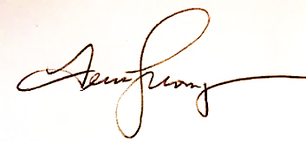
Terri Thompson
Greater Hartford TIM Coalition Chair
Traffic Incident Management Program
http://crcog.org/traffic-incident-management-update/
Capitol Region Council of Governments (CRCOG)
241 Main Street, Hartford, CT 06106
Direct 860-724-4242

Electronic Distribution
TIM Coalition members
Donna Shea – UConn Training and Technical Assistance Center, donna.shea@uconn.edu
Mary McCarthy – UConn Training and Technical Assistance Center, mary.c.mccarthy@uconn.edu

Attachments:
TIM Responder Trng Announcement - May 2023 - Jan 2024.pdf

