CT DOT Traffic Incident Management Team: 2023 Executive Year-End Briefing

As we bid farewell to 2023, I am delighted to share the remarkable achievements of the CT DOT Traffic Incident Management Team in our relentless pursuit of safety training and excellence.

This year, our team orchestrated an extensive training program, conducting 75 training sessions statewide and reaching a commendable 2,374 first responders. The impact of these efforts reverberated across various sectors: 302 police officers, 621 fire department members, 72 tow operators, 79 EMS professionals, 1,137 DOT/DPW personnel, and 163 individuals from other CERT teams and support agencies. This coupled with 2022’s classes make 103 program total trainings and a grand total of 3036 first responders.
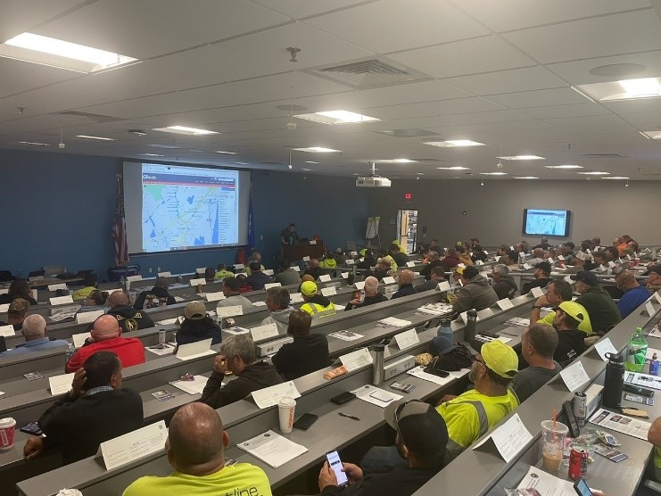
Picture: 121 CT DOT maintenance employees at TIM training Willimantic Fire School

Beyond training, our commitment to continuous improvement was evident in the 16 after-incident reviews. These sessions served as invaluable forums to distill lessons learned and embrace best practices from major traffic incidents, ensuring a dynamic and responsive approach to our work. These after actions are held by bringing together all responder groups from an incident in one room and review the timeline of events and discuss challenges and successes from the event. They have proved to save time in events post review in communication and clearance times in some cases we have seen 75% reduction in closure times with similar incidents involving the same groups of responders.

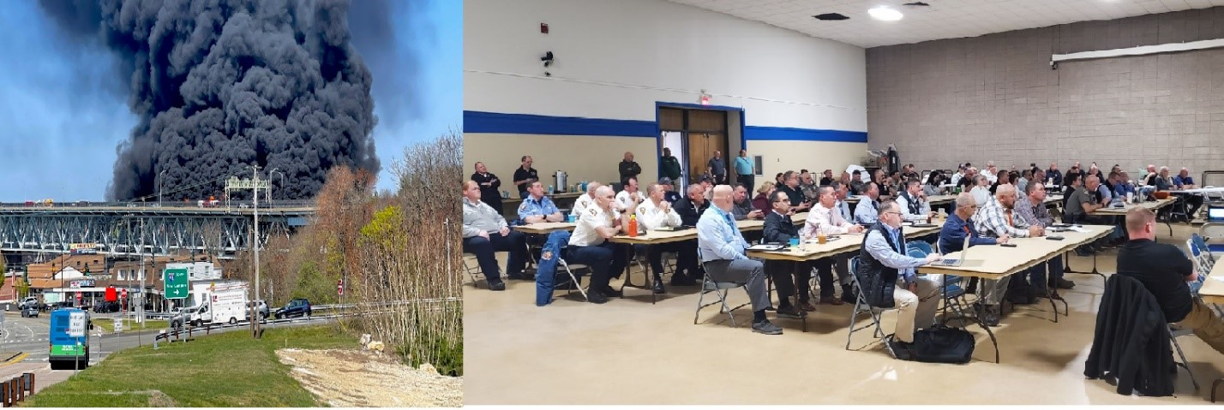
Pictures: Gold Star Fire and resulting after action review held with all agencies that responded to the fire

A pivotal milestone of the year was the comprehensive review and update of legacy diversion routes for major interstates, last revised in 1997. Collaborating with municipalities along the corridors of Interstate 95, Interstate 91, and Interstate 84, we elevated these plans to contemporary standards, enhancing our preparedness for unforeseen events. In these individual meetings totaling over 65 we brought together local first responders, town officials, local CT DOT management, and regional planners to review and discuss the major interstate diversion routes used for major road closures. We included a program to also discuss how DOT can assist these communities in traffic management, resources CT DOT has for traveler information, emergency contacts, and relationship building to help foster a better relationship with all the towns along these corridors. We have been seeing this relationship bloom as Highway Operations is receiving better communication from these municipalities and interaction during events and non-emergency requests.

We also held a TIM training for two local groups of technical high school criminal justice and protection services shops, the Vinal Tech and Bullard Tech schools sent their outgoing seniors to us for three days of training in 2023. We hosted them and they received the TIM training as well as we had them spend a day operating in the Newington Operations center taking real calls and then placing them into the system and up on CT Roads or interactive website. They operated cameras and did all the functions of the operators and will use this in their future careers as emergency responders.

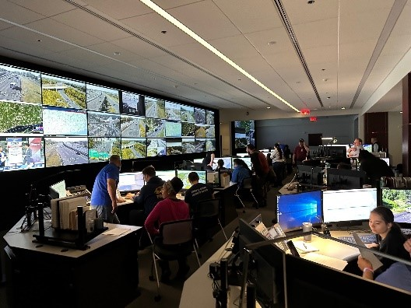
Picture: High school students moving through the center operating and taking calls

Looking forward, 2023 set the stage for an even more impactful 2024. With over 40 training sessions already scheduled, our team remains steadfast in its mission to equip first responders with the tools necessary for safe operations on our state's roads.

We are setting a goal higher than last year in numbers of classes and attendees. With last year’s state legislation requiring all Police officers in CT to attend CT DOT’s Traffic Incident Management training we have our work set out for us. The training team has all received the required certification as instructors from the Connecticut Police Officer and Standards and Training council (POST) this requirement makes us able to provide the training to all new police recruits and to all officers in CT, we are estimating 7578 officers needing the training by October of 2024 to meet the legislation. Then after this initial training 3-hour refresher every 3 years for all officers in CT.

Exciting strides await us in 2024 as we integrate Unmanned Aerial Systems (UAS) operations into our traffic incident toolbox. The addition of UAS pilots to our Highway Operations team marks a pivotal enhancement, enabling live streaming of major traffic events internally. This real-time insight elevates our situational awareness during the recovery process, aids in managing traffic delays, and provides valuable post-incident review material.

While ground-level streaming has been tested in the past, incorporating UAS technology opens new perspectives and opportunities for expeditiously clearing scenes. This addition promises to revolutionize our approach, offering innovative ways to leverage technology for swifter and more efficient incident resolution.

As we turn the page on this chapter, let us eagerly anticipate a future where incident safety is not merely a goal but a shared reality for all. I am particularly proud to announce that in 2023, we achieved a significant milestone—no first responder was struck and killed on our roadways. This marks the first time in many years, and while injuries did occur, the absence of fatal incidents for our first responders is a testament to the effectiveness of the training we have diligently provided.

Here's to the promising future ahead and the continued commitment to making our roadways safer for everyone.
No retrospective would be complete without acknowledging the unwavering commitment and indispensable contributions of our exceptional training team, without whom none of our accomplishments would be possible.

Our instructing team, comprised of seasoned professionals, has been instrumental in shaping the success of our training initiatives. I extend my gratitude to Ret. CSP LT. Robert Derry, Ret. CSP Sergeant Scott Leonard, Old Saybrook Fire Captain of Training Todd Steward, Bridgeport Operations Manager Peter Silva, and our very own CT DOT TIM Coordinator, Aidan Neely. Each member brings a wealth of experience and expertise, enriching our training programs and ensuring their effectiveness.

A special mention goes to Toni Zanks at DOT, whose support in scheduling and documentation of DOT personnel has been invaluable. This support has enabled us to extend our training reach to almost all of our DOT maintenance staff, reinforcing the impact of our program.

Also Special thanks to Terri Thompson from Capitol Region Council of Governments CRCOG, DEEP, CT Fire Academy and all those who supported the program in materials and getting the word out of classes.

It is with great pride that I highlight the incredible achievements of our team. Consistently ranking in the top ten nationwide in federal highway training numbers each 2-week cycle is a testament to the dedication and hard work of these individuals. Their efforts have been pivotal in making our program the success that it is today.

As we reflect on the positive trajectory we've set, I extend my heartfelt appreciation to this dedicated team. Their passion for excellence has not only elevated our programs but has also positioned us as leaders in our field. Here's to the incredible team that made all of this possible!

Respectfully,
Aidan Neely
CT DOT Highway Operations Center Planner 3
DOT T.I.M. Coordinator & CTIC Center Liaison
Newington Headquarters Operation Center
2800 Berlin Turnpike, Newington , CT 06131
Office: 860-594-3454
State Cell: 860-818-4586
